Project Stork Inc.
A New York Non-profit Corporation
BYLAWS

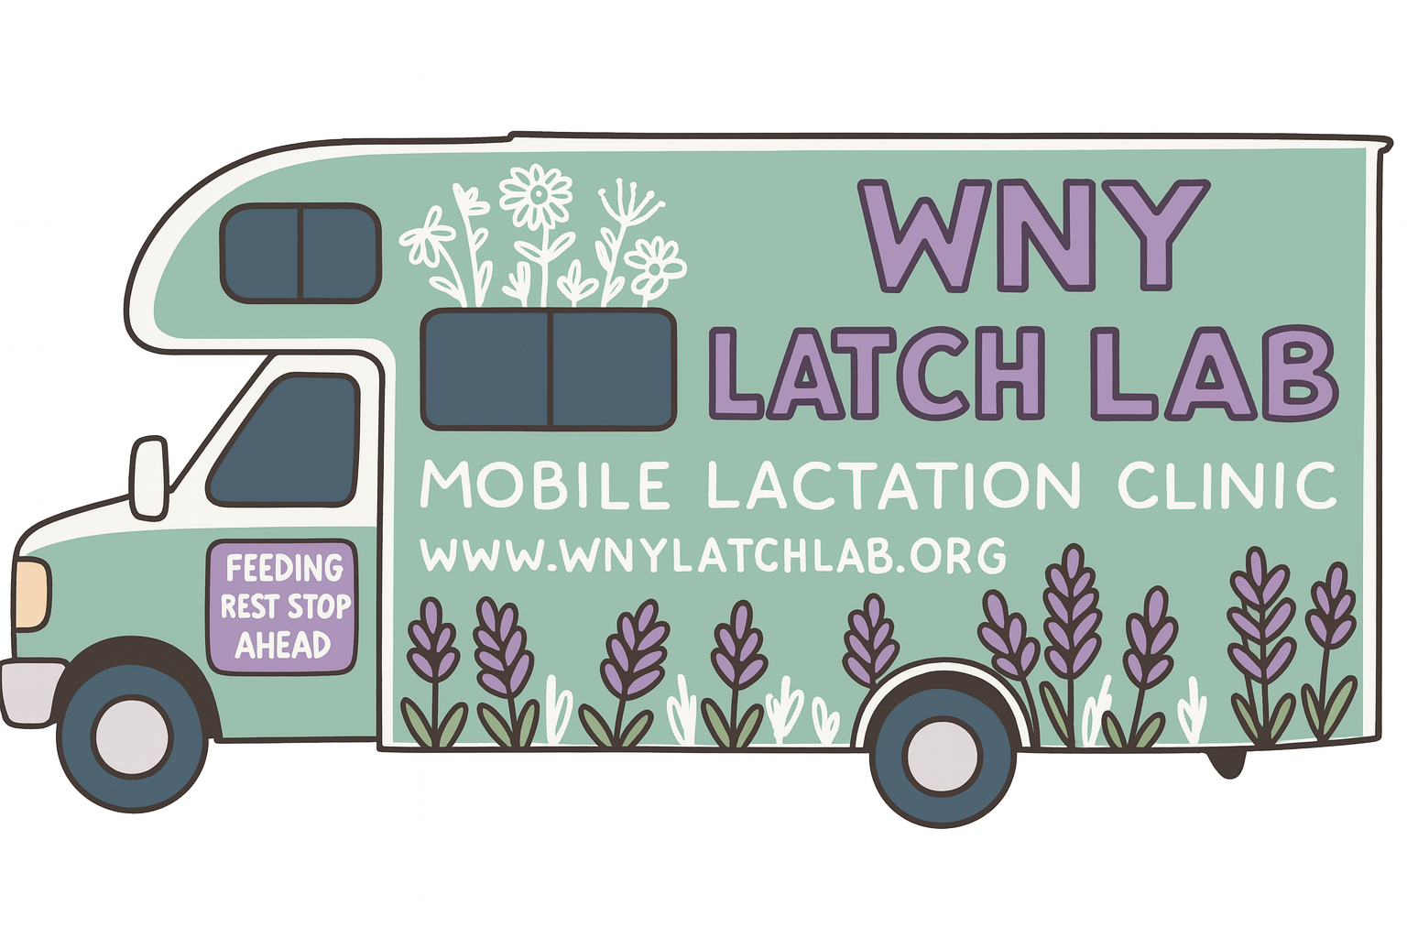

Bylaws

Article I – Name & Mission

Section 1. Name
The name of this organization is Project Stork Inc., a New York nonprofit corporation.

Section 2. Mission
Project Stork Inc. exists to support families through education and charitable services, with a focus on lactation, maternal health, and infant well-being.

Article II – Nonprofit Status & Powers

Section 1. Nonprofit Status
Project Stork Inc. is organized exclusively for charitable and educational purposes under Section 501(c)(3) of the Internal Revenue Code.

Section 2. Powers
The organization may carry out all lawful activities that support its mission, including:

Providing direct services and education.

Partnering with other organizations.

Accepting financial and in-kind donations.

Section 3. Limitations

No earnings may benefit directors, officers, or private individuals, except for fair and reasonable compensation for services provided.

Activities must comply with nonprofit laws and remain consistent with charitable purposes.

Section 4. Dissolution
If Project Stork Inc. dissolves, remaining assets shall be distributed to another 501(c)(3) nonprofit with a similar mission, preferably located in New York. If none is available, assets will be distributed as required by state law.

Article III – Board of Directors

Section 1. Authority
The board of directors governs the organization, ensuring that its mission, finances, and programs are responsibly managed.

Section 2. Size
The board shall have no fewer than 4 and no more than 15 members.

Section 3. Terms

Directors serve two-year terms, beginning January 1.

Terms are staggered so that about half expire each year.

Directors may serve multiple consecutive terms.

Section 4. Elections

Elections are held annually in November.

New directors begin service in January.

Section 5. Vacancies
Vacancies may be filled by a majority board vote. Appointees serve the remainder of the term.

Section 6. Removal
A director may be removed by two-thirds (⅔) vote of the board for:

Missing two or more unexcused meetings in a year, or

Other reasons determined by the board, provided the director receives notice and an opportunity to be heard.

Section 7. Meetings

The board meets at least four times per year.

Special meetings may be called with at least 2 days’ notice.

A majority of directors constitutes a quorum.

Decisions require a majority vote of those present.

Meetings may be held in person, by video, or by phone.

Section 8. Compensation
Board members are not paid for service but may be reimbursed for reasonable expenses. They may be compensated separately for professional services provided, if approved under the conflict-of-interest policy.

Article IV – Officers

Section 1. Officers
The officers are:

President – chairs board meetings and provides leadership.

Secretary – keeps minutes and ensures proper notice of meetings.

Treasurer – oversees finances, budgets, and reporting.

The board may create additional officer roles if needed.

Section 2. Terms
Officers serve one- or two-year terms and may be re-elected.

Section 3. Removal
Officers may be removed at any time by a majority vote of the board.

Article V – Committees

The board may form committees as needed. Committees report to the board and may not take final action on matters reserved for the board (such as approving bylaws, electing directors, or amending policies).

Article VI – Policies & Standards

Section 1. Conflict of Interest
Directors and officers must disclose potential conflicts and may not vote on matters where they have a personal interest.

Section 2. Nondiscrimination
Project Stork Inc. does not discriminate based on age, race, religion, gender, sexual orientation, national origin, disability, or any other protected status.

Section 3. Transparency
The organization will make required public documents (such as IRS Form 990 and bylaws) available upon request and on its website.

Section 4. Whistleblower Protection
Directors, officers, employees, or volunteers who report suspected wrongdoing in good faith are protected from retaliation.

Article VII – Finances & Records

Section 1. Fiscal Year
The fiscal year runs from January 1 to December 31.

Section 2. Financial Controls

All checks and contracts must be signed by authorized officers.

The board approves an annual budget and reviews financial reports regularly.

Section 3. Records
The organization maintains accurate financial and organizational records, including meeting minutes.

Section 4. Document Retention
Records are retained as required by law and organizational policy.

Article VIII – Indemnification

To the fullest extent permitted by law, Project Stork Inc. shall indemnify its directors, officers, and employees who act in good faith and in the best interest of the organization.

Article IX – Amendments

These bylaws may be amended by a two-thirds (⅔) vote of the board, provided that changes do not affect nonprofit status and remain consistent with the Articles of Incorporation.

Name | Signature & Date
Kayla Shuknecht RN | Kayla Shuknecht 11/18/2025

Certification
I certify that the Bylaws were adopted by the Board of Directors of Project Stork Inc. on ______________________, 2025.

Secretary ________________________________
Date: ______________________

